**Installation Guide**

1. Download the Python 3 Installer
2. Run the Installer
3. **Important:** You want to be sure to check the box that says Add Python 3.x to PATH

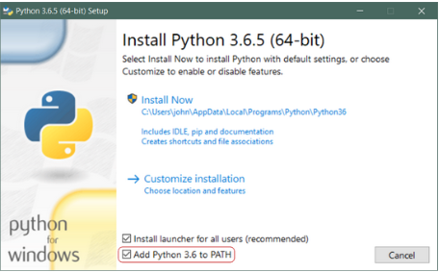

1. Verify the python version
   1. Open the command prompt
   2. Run “python --version”
2. Install nltk package
   1. Open the command prompt
   2. Run “pip install nltk”
   3. Run “python”
   4. Run “import nltk”
   5. Run “nltk.download()”
   6. You will get one popup, click on download button

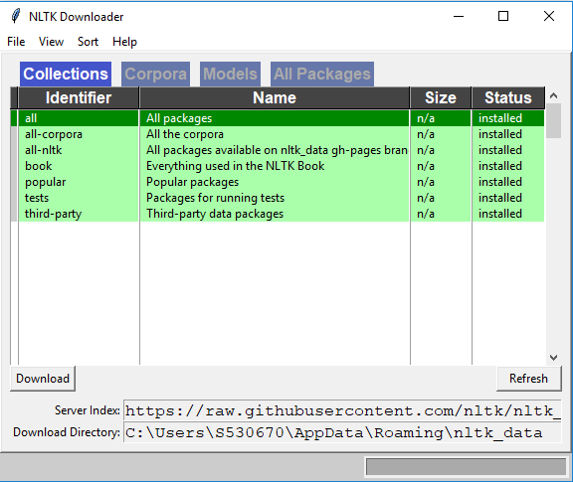

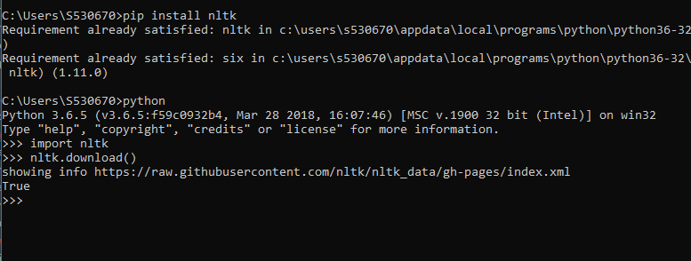

1. Clone the repository
   1. Link: <https://github.com/s530670/Study-Sentiment-Analyzer.git>

**Instruction to run Custom Analyzer**

1. Go to cloned folder
2. Folder named “rt-polaritydata” has **trainingData.txt** which contains all training data. If you are interested to change the training data, change the content of it.
3. Open the command prompt
4. Run “python CustomWordClassification.py” , it will classify the words based upon the polarity
5. Wait until it shows **Data ready** message.
6. Run “python CustomAnalyzer.py”